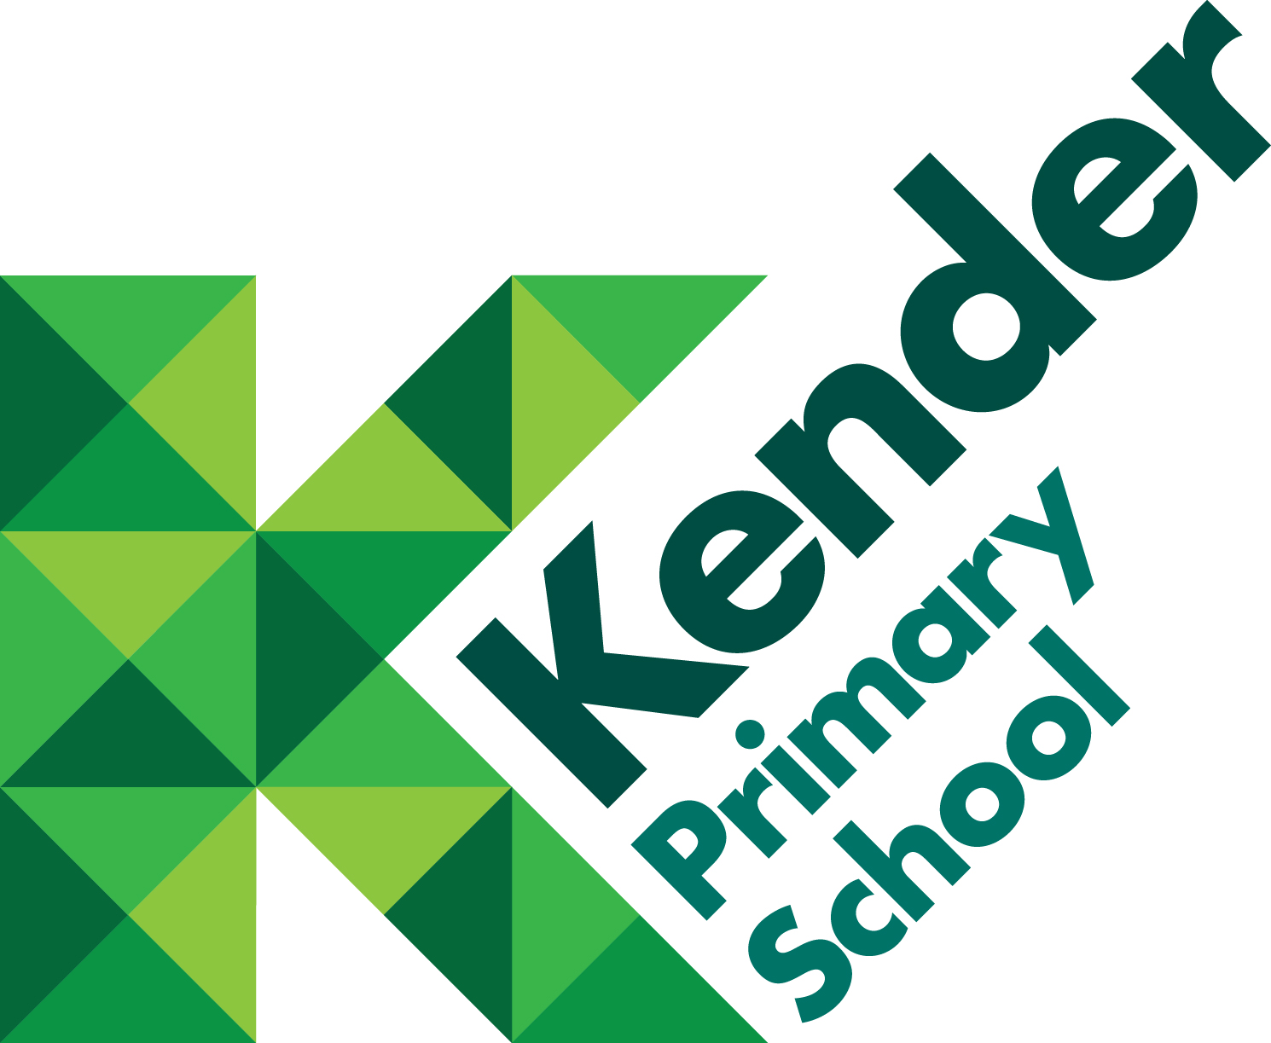

Sex and Relationship Education Policy

Core Values

Readiness | Resilience | Respect

School Values

Independence  Co-operation  Responsibility  Kindness | Ambition  Initiative  Confidence  Honesty | Compassion  Enjoyment  Celebration  Individuality

Reviewed: Summer 2018
Introduction

At Kender Primary School we believe that Sex and Relationship Education (SRE) is a lifelong learning process of acquiring information, developing skills and forming positive beliefs and attitude about sex, sexuality, relationships and feelings.

Effective SRE teaches children the skills needed to develop healthy relationships and it supports their moral development, helping them to understand themselves and to respect and care for others. It is about the understanding of the importance of marriage for family life, stable and loving relationships, respect, love and care. It is also about the teaching of sex, sexuality, and sexual health.

Rationale or statutory requirements

This policy was written in accordance with:
- Sex and Relationship Education Guidance (ref DfE 0116/2000) - DfE guidance
- Sex and Relationships Education (SRE) for the 21st Century – Supplementary advice provided by PSHE Association

Our strategic aims and objectives

SRE in our school aims enable pupils to:
- Develop confidence in talking, listening and thinking about feelings and relationships;
- Identify and name the parts of the body and describe how their bodies work;
- Protect themselves and know when and who to ask for help and support;
- Be prepared for puberty.

Our practice

Pupils need to be given accurate information and helped to develop skills to enable them to understand difference and respect themselves and others and for the purpose also of preventing and removing prejudice.

A planned, progressive programme of SRE gradually and appropriately begins to prepare our children for adult life. It teaches the skills they need to fully manage the natural physical and emotional changes that will happen to them as they grow and mature into healthy, confident and responsible adults.

In line with national recommendations, SRE at Kender will be delivered through the PSHE (Personal, Social and Health Education), Science, SEAL (Social and Emotional Aspects of Learning) and Citizenship frameworks. Kender follows The Christopher Winter Project Scheme of Work for SRE, which is led by the class teachers through discussions.

SRE is taught to each year group, starting in Reception.

SRE at Kender covers the following areas:

Attitudes and Values
• Learning about the values of family life and stable relationships.
• Learning the value of respect, love and care.
• Exploring, considering and understanding moral dilemmas.
• Developing critical thinking as part of decision making.

Personal and Social Skills
- Learning to manage emotions and relationships confidently and sensitively.
- Developing self-respect and empathy for others
- Learning to make choices based on understanding of differences and with the absence of prejudice
- Providing opportunities for young people to develop the ability to understand the consequences of their decisions and actions
- To manage conflict.

Knowledge and Understanding
• Information about healthier, safer lifestyles
• Physical development
• Emotions, relationships and reproduction.

Pupils at Kender will also develop their sensitivity and tolerance towards others through:
- RE and collective worship
- Circle Time
- SEAL (Social and Emotional Aspects of Learning)

Sex and relationship education is usually delivered in mixed gender groups. However, there may be occasions where single gender groups are more appropriate and relevant.

SRE and Science Curriculum
SRE will be taught along the current Science curriculum. Parents do not have the right to withdraw their child/children from these lessons.

National Curriculum Science Programme of Study
Key Stage 1
- Identify, name, draw and label the basic parts of the human body and say which part of the body is associated with each sense
- Notice that animals, including humans, have offspring which grow into adults
- Describe the importance for humans of exercise, eating the right amounts of different types of food, and hygiene

Key Stage 2
- Identify that animals, including humans, need the right types and amount of nutrition, and that they cannot make their own food; they get nutrition from what they eat
- Identify that humans and some other animals have skeletons and muscles for support, protection and movement
- Describe the changes as humans develop to old age
- Describe the life process for reproduction in some plants and animals
- Identify and name the main parts of the
- Recognise that living things produce offspring of some kind, but normally offspring vary and are not identical to their parents

Specific SRE Objectives

Year | Topic/Lesson | Learning Intentions | Learning Outcomes
Reception | Our Day | To consider the routines and patterns of a typical day | Understand some areas in which the children can look after themselves eg dressing and undressing
 | Keeping ourselves clean | To understand why hygiene is important | Explain why it is important to keep clean  Understand some basic hygiene routines
 | Families | To recognise that all families are different | Identify different members of the family.  Understand how members of a family can help each other

Year | Topic/Lesson | Learning Intentions | Learning Outcomes
Year 1 | Keeping clean | To understand some basic hygiene principles | Know how to keep clean and look after oneself
 | Growing and Changing | To introduce the concept of growing and changing | Understand that babies become children and then adults  Know the differences between boy and girl babies
 | Families and Care | To explore different types of families and who to ask for help | Know there are different types of families  Know which people we can ask for help

Year | Topic/Lesson | Learning Intentions | Learning Outcomes
Year 2 | Differences: Boys and Girls | To introduce the concept of male and female and gender stereotypes  To identify differences between males and females | Understand that some people have fixed ideas about what boys and girls can do  Describe the difference between male and female babies
 | Differences: Make and Female | To explore some of the differences between males and females and to understand how this is part of the lifecycle | Describe some differences between male and female animals  Understand that making a new life needs a male and a female
 | Naming the Body parts | To focus on sexual difference and name body parts | Describe the physical differences between males and females  Name the male and female body parts

Year | Topic/Lesson | Learning Intentions | Learning Outcomes
Year 3 | Differences: Male and Female | To explore the differences between males and females and to name the body parts | Know some differences and similarities between males and females  Name male and female body parts using agreed words
 | Personal Space | To consider touch and to know that a person has the right to say what they like and dislike | Identify different types of touch that people like and do not like.  Understand personal space  Talk about ways of dealing with unwanted touch
 | Family Differences | To explore different types of families and who to go to for help and support | Understand that all families are different and have different family members  Identify who to go to for help and support

Year | Topic/ Lesson | Learning Intentions | Learning Outcomes
Year 4 | Growing and Changing | To explore the human lifecycle | Describe the main stages of the human lifecycle  Describe the body changes that happen when a child grows up
 | What is Puberty? | To identify some basic facts about puberty | Discuss male and female body parts using agreed words  Know some of the changes, which happen to the body during puberty
 | Puberty changes and reproduction | To explore how puberty is linked to reproduction | Know about the physical and emotional changes that happen in puberty  Understand that children change into adults so that they are able to reproduce

Year | Topic/ Lesson | Learning Intentions | Learning Outcomes
Year 5 | Talking about Puberty | To explore the emotional and physical changes occurring in puberty | Explain the main physical and emotional changes that happen during puberty  Ask questions about puberty with confidence
 | Male and Female changes | To understand male and female puberty changes in more detail | Understand how puberty affects the reproductive organs  Describe how to manage physical and emotional changes
 | Puberty and Hygiene | To explore the impact of puberty on the body and the importance of physical hygiene To explore ways to get support during puberty | Explain how to stay clean during puberty  Describe how emotions change during puberty Know how to get help and support during puberty

Year | Topic/ Lesson | Learning Intentions | Learning Outcomes
Year 6 | Puberty and reproduction | To consider puberty and reproduction | Describe how and why the body changes during puberty in preparation for reproduction  Talk about puberty and reproduction with confidence
 | Understanding relationships | Consider physical & emotional behaviour in relationships | Discuss different types of adult relationships with confidence  Know what form of touching is appropriate
 | Conception and Pregnancy | To explore the process of conception and pregnancy | Describe the decisions that have to be made before having a baby  Know some basic facts about pregnancy and conception
 | Communicating in Relationships | To explore positive and negative ways of communicating in a relationship | To have considered when it is appropriate to share personal/ private information in a relationship  To know how and where to get support if an online relationship goes wrong

Working in Partnership with Parents
Parents are the key people in:
• Teaching their children about sex and relationships
• Maintaining the culture and ethos of the family
• Helping their children cope with the emotional and physical aspects of growing up
• Preparing them for the challenges and responsibilities that sexual maturity brings.

The school is committed to working with parent and carers and informs parents by letter when pupils will be studying SRE.

Parents’ Right to Withdrawal
Parents have the right to withdraw their children from all or part of the SRE provided except for those parts included in the statutory National Curriculum. Parents are asked to contact the Headteacher who will be available to discuss any concerns.

Working with the Wider Community
A range of people in the wider community including health professionals, social workers, youth workers and visitors also provide elements of sex and relationship education. If people other than school staff support SRE provision, they will be made aware of and agree to abide to our SRE policy before any support is given.

Confidentiality and Child Protection
SRE will take place in a secure and supportive environment however the children will be made aware that teachers cannot offer unconditional confidentiality. All staff involved in delivering and supporting SRE should be alert to the signs of abuse, neglect and exploitation. The school has a separate Child Protection Policy. Effective SRE may bring about disclosures of child protection issues and staff should be aware of the procedures for reporting their concerns.

Links with other policies
This policy links particularly to the following policies: Confidentiality, PHSCE, Healthy and Safety, Drugs and Alcohol Education, Safeguarding and Child Protection, Behaviour and Anti-bullying.
Review and Monitoring
Governors review the Sex and Relationships Education Policy every two years. The PSHE Co-ordinator monitors the SRE programme.

Equal Opportunities
The school is committed to the provision of SRE to all of its pupils. Our programme aims to respond to the diversity of children’s cultures, faiths and family backgrounds.

