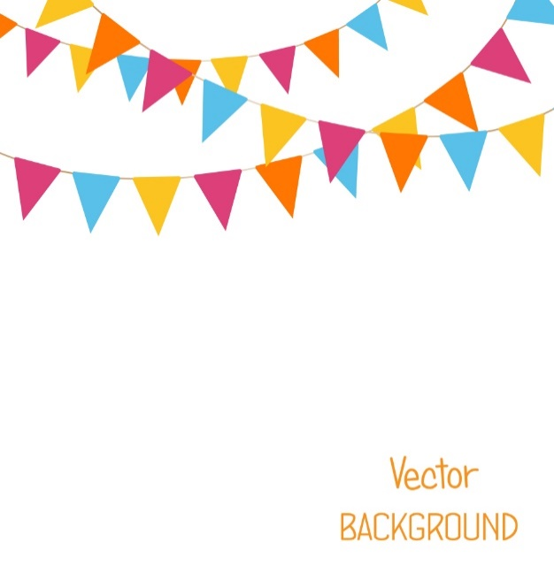



The Queen’s
Platinum Jubilee
Theme Day Menu

Coronation Chicken
Or
Queen’s Coronation Quorn

with

Crown Jewelled Celebration Rice
Broccoli
Carrots

Victoria Sponge Cake
Or
Apple Pie with Cream

