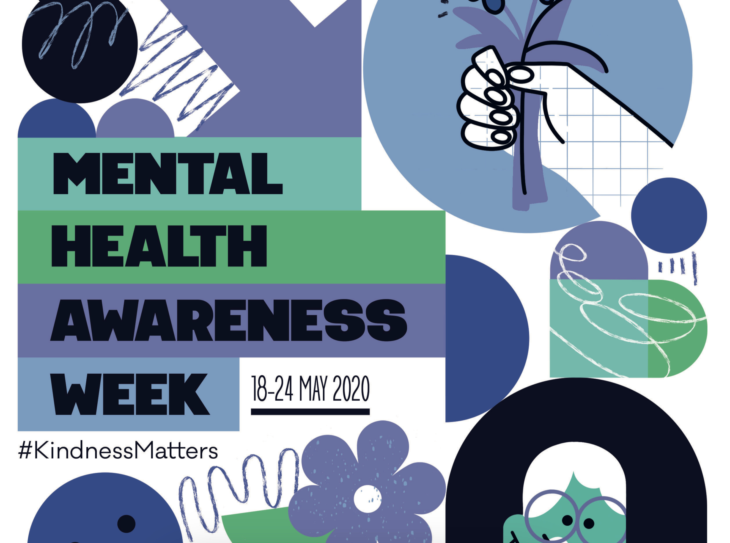

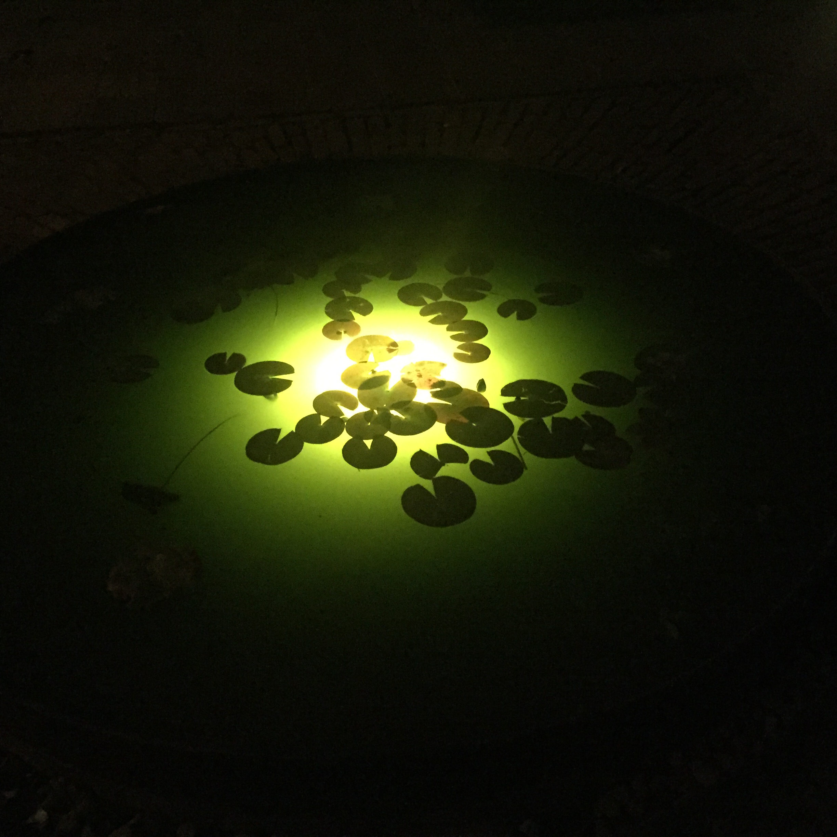

https://www.mentalhealth.org.uk/campaigns/mental-health-awareness-week/kindness-stories
This week is Mental Health awareness week the theme is KINDNESS.
During this time I have seen and heard of so many people being kinder to each other, helping people less fortunate than themselves by delivering shopping to the elderly and unwell, calling loved ones regularly and letting them know they care. NHS and health workers are going above and beyond saving peoples lives and giving them the care that they deserve.
Kender school wellbeing newsletter wk 9 18 May 2020

Be Kind to yourself.....
As well as being kind to others it is really important to be kind to your self. Take time for yourself and do the things you enjoy.

‘We are all in this together’
‘We will be able to see each other soon, this will end and life will go back to normal
Stay safe
Stay well
Stay Happy
Call a friend or family member that you haven’t spoken to in a while and tell them you are thinking of them
1
Smile 😃
it could make someones day!
2

Asking your mum or DAd if you can do anything to help with cooking dinner Or house hold chores, make them a cup of tea or just ask them if they are ok.
3

Simple Acts of Kindness
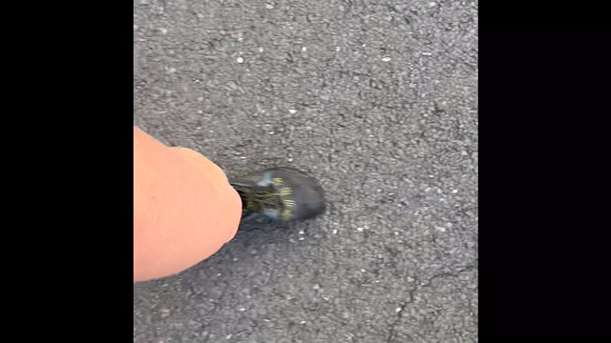
Kender wellbeing newsletter 18 MAy 2020

Below is a short video about coping during lockdown and the things we can do to make ourselves feel better.
https://urldefense.proofpoint.com/v2/url?u=https-3A__liveuclac-2Dmy.sharepoint.com_-3Av-3A_g_personal_ucjurap-5Fucl-5Fac-5Fuk_ETDyICi5MKtLrLl1X6neXhkB-5FM9TddpcVniMcSpR3Kr1XQ-3Fe-3DdEUvBZ&d=DwMGaQ&c=OMjwGp47Ad5otWI0__lpOg&r=HH8VfidN4x3CQpkvdpJwWhpuIMWTaSKPdGRp0qqBvyE&m=9gso7how8LYWv-awB7izGlwJYjyNhFjXK1dXvzjtrqM&s=rIXKu4Fht2V0PNCl064qV9XYdRrSMNeMb6haV6q8bhE&e=

A Wellbeing video message I made two weeks ago in week 7! This is the beginning of week 9, I can’t believe it! Stay Safe and Well. Get outside, it beautiful out there.

